Adverbs of Affirmation

🔹 What Are Adverbs of Affirmation?
# Source: AI Source: Provided by: [Data Path: Persons Table -> ID Column: 1, Name_En Column: Motasem Essam] -> From: [Chatgpt (GPT-4-turbo)] on [7/27/2025]
Adverbs of affirmation are used to show that a statement is true, to express agreement, certainty, or approval.
They answer the implied question: 👉 "Is it true?" — and say YES, it is.

✅ Common Adverbs of Affirmation
# Source: AI Source: Provided by: [Data Path: Persons Table -> ID Column: 1, Name_En Column: Motasem Essam] -> From: [Chatgpt (GPT-4-turbo)] on [7/27/2025]
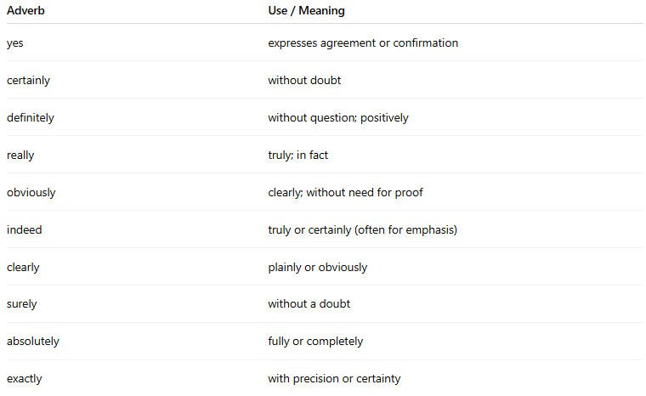
Adverb | Use / Meaning
yes | expresses agreement or confirmation
certainly | without doubt
definitely | without question; positively
really | truly; in fact
obviously | clearly; without need for proof
indeed | truly or certainly (often for emphasis)
clearly | plainly or obviously
surely | without a doubt
absolutely | fully or completely
exactly | with precision or certainty

📚 Examples in Sentences
# Source: AI Source: Provided by: [Data Path: Persons Table -> ID Column: 1, Name_En Column: Motasem Essam] -> From: [Chatgpt (GPT-4-turbo)] on [7/27/2025]
- Yes, I agree with you.
- She will definitely be there on time.
- He is certainly the best candidate.
- You are really kind.
- That is obviously a mistake.
- Indeed, he is a genius.
- We are absolutely ready.

🧠 Key Notes
# Source: AI Source: Provided by: [Data Path: Persons Table -> ID Column: 1, Name_En Column: Motasem Essam] -> From: [Chatgpt (GPT-4-turbo)] on [7/27/2025]
- These adverbs often appear at the beginning of a sentence for emphasis:
✅ Certainly, I can help you.
- They can also appear after the verb:
✅ He is definitely coming.
- They strengthen the truth or positivity of what is being said.

